May 27, 2015
http://the-star.co.ke/news/who-will-break-kenya-coffee-curse#sthash.7esgsLGw.nXItgEIQ.dpbs
Who Will Break This Kenya Coffee 'Curse' ?

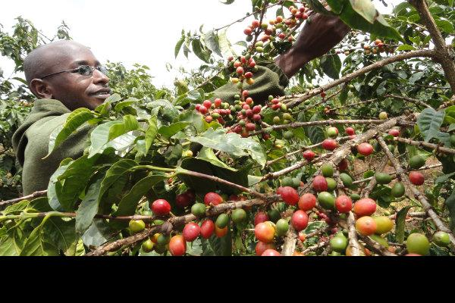
A farmer harvests coffee.Photo/File
May 27, 2015
BY OKECH KENDO
Kenyans wake up, and smell the coffee - literally. There is no metaphor here. It's the plain aroma of freshly brewed coffee. A cup of coffee awakens your senses, enriches your day, and invigorates the whole body. But a classic cup of blended coffee, we are told, makes the whole body fire on all cylinders.
Coffee smells great, and tastes fine for those who enjoy the original and natural sense of smell and taste. The raw material for this beverage is a cash crop from this clime - Kenya, the mythical land of diversity.
Kenya is an internationally acclaimed coffee grower, but the country does not have a major stake in this beverage of choice. Kenya grows top-class coffee. It then exports the raw material cheaply, and later imports processed coffee much more expensively.
Blended coffee comes with exotic brand names, even from the Orient. The Chinese have added value and a medicinal dimension to coffee, with a blend of Asian mushroom, reishi (ganoderma lucidum). For more than 2,000 years, this mushroom has been used to promote health, increase longevity and prevent or treat many diseases.
Ganoderma is a licensed treatment in Japan and China. Japanese doctors recognise ganoderma's calming or sedative benefits in reducing emotional turmoil resulting from long-term stress. It is still used in treating arthritis, hardening of the arteries, liver disease, altitude sickness, and strained breath associated with coronary heart disease.
Doctors also say ganoderma fine-tunes the immune system thereby serving as a barrier to most diseases.
Before the Japanese developed a system of growing this Chinese mushroom, ganoderma was accessible only to the nobility and the very wealthy. Now they have injected it into Kenyan coffee.
Organo Gold, the promoters of coffee blended with ganoderma, say they are "bringing the treasures of the earth ... to the people of the world".
Imported coffee is packaged so classily that it seems the raw material did not come from the Central highlands of the Agikuyu cradle or from Kisii, the fertile abode of the Abagusii - God's legendary bathroom.
Coffee is not a luxury anymore. The coffee craze is growing worldwide, and it is slipping into Kenya. There is Starbucks, with its $5 Cup. The American McDonalds is famous for the Affordable McCafe.
Then there is Burger King with the Iced Mocha. There is also Dunkin Donuts, which changed its logo from a doughnut to coffee. Nestle introduced Nescafé to the American market, and Subway is in town with a coffee breakfast menu. There is also Java, ArtCafe, and other coffee houses in Nairobi.
Consider some facts about this wonder beverage, whose raw material grows in the highland villages across Kenya. The cash crop grows just fine when the climate is right, and the soil is cultured to suit the plant.
Coffee is one of the world's most consumed beverage. It is the world's largest single traded commodity, after oil. Yet the world talks of petro-dollars, but never coffee bucks or coffee-dollars. Coffee is much more expensive than petroleum. But coffee is not to Kenya what oil is to Qatar.
About 1.6 billion cups of coffee are consumed each day. More than 80 per cent of the people over age 18 have consumed coffee. Speciality coffee sales are also increasing - globally - by 20 per cent year year. But Kenyan coffee growers are not doing any better, economically.
Facts also show millions of citizens of the world pay up to $4 (Sh320) per cup. Many drink three to five cups per day. Consumers drink more cups of the beverage in their houses during breakfast or in the evening. They drink more coffee, sometimes twice, at work. Ardent coffee consumers drink some more on their way home from work.
Invites like, "Can we have coffee after work?" are common for those who can afford it, have the time, and the appetite. Many middle class Kenyans, and above, have coffee in their houses, at work, and on their way home after the rat race.
It does not matter which taste of coffee - consumers who love coffee just prefer coffee. Coffee comes in various tastes, with a touch of class, like the raw material did not come from Ndumberi in Kiambu or Obaracho in Kisii.
There is 'gourmet cafe latte' - a smooth Italian-inspired latte with a mellow taste, made from fine Arabica coffee beans, blended with cream and sugar. Marketers say this is a good way start the morning.
There is also gourmet cafe mocha, rich coffee with a hint of decadent chocolate. Blended with cocoa from Ghana, marketers say this qualifies for after dinner or for a mid-afternoon pick-me-up taste.
Then there is gourmet hot chocolate, described as 'taste comfort in every sweet and creamy cup'. Marketers tell us, this has a silky smooth texture in a "mug full of happiness for the whole family.
Yet coffee by any other brand name is coffee, whose raw material comes from Ndumberi and Nyanturago.
The lead question then is, what are our agricultural engineers and food processors doing about coffee? Are they working on a technology that can see this wonder beverage processed locally, blend with moringa or marubaine, branded and then exported?
Good morning agricultural engineers at the University of Nairobi and the Jomo Kenyatta University of Agriculture and Technology. Now you can smell the coffee, but can you add value to Kenya's coffee?
- See more at: http://the-star.co.ke/news/who-will-break-kenya-coffee-curse#sthash.7esgsLGw.nXItgEIQ.dpuf

